1. The distribution of the Happiness score across: countries and continents

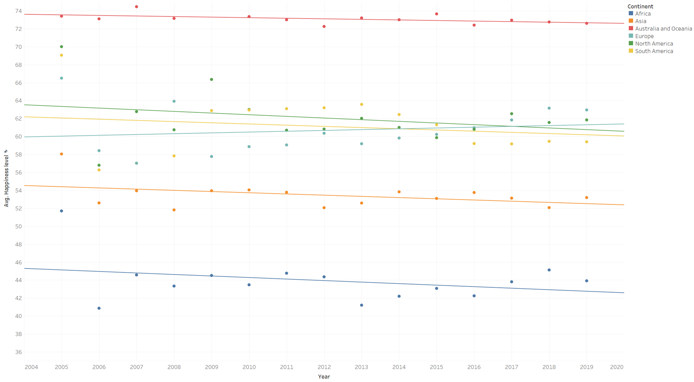

Continent with Maximum Average Happiness: Australia and Oceania.

Average Happiness level in Australia and Oceania: 73/100

Continent with Minimal Average Happiness: Africa.

Average Happiness level in Africa: 43/100

There is a trend towards a decrease in the level of happiness on all continents except Europe.

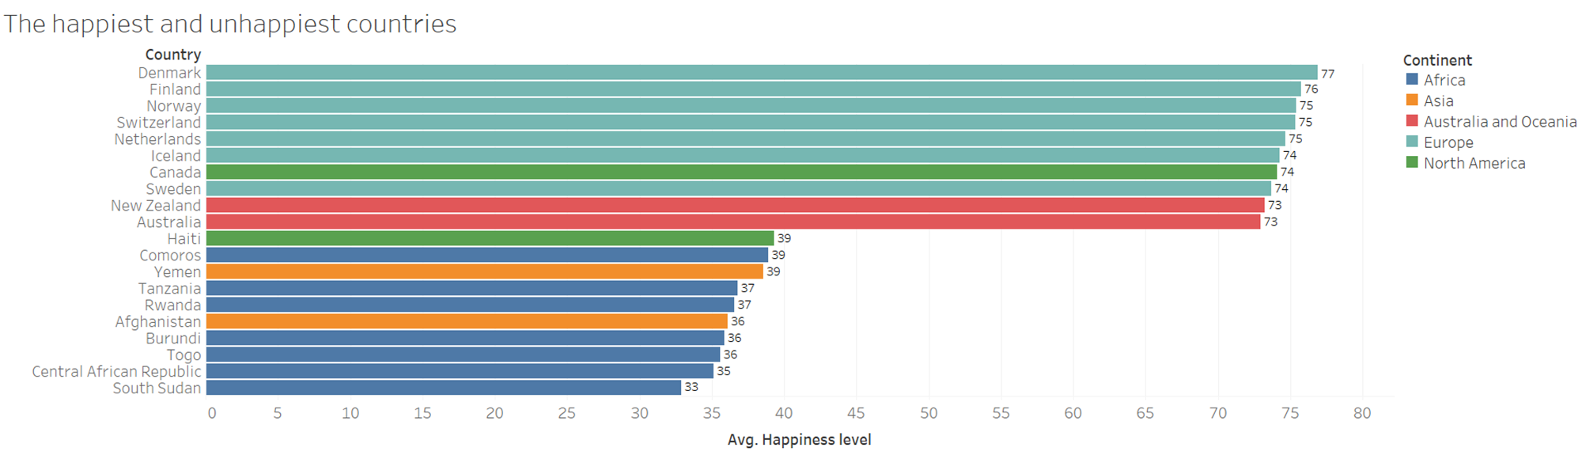

1. Change of happiness through the years

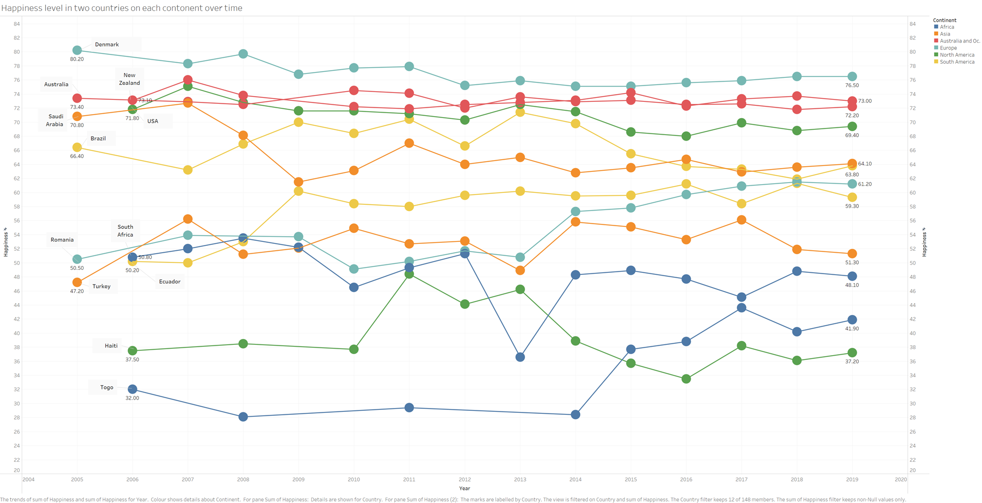

1. Which other variables correlate with the happiness score?

